Environmental Responsibilities

Recycling: greenteam@wolfson.ox.ac.uk
As a college resident, it is your responsibility to dispose of waste appropriately. Please study the poster in your college accommodation, and the bins in the waste disposal area between the kitchens and the front car park, which demonstrate the items that are recyclable in Oxford.

General Recycling:
- Metal (e.g. tin cans, jar lids)
- Paper & cardboard
- Most plastic (if it is labelled as recyclable)
These items can be put in the BLUE BINS in your communal areas (either loose or in the clear plastic bags provided by college) and taken to the BLUE BINS in the outdoor waste disposal areas when full.

Glass:
Glass has a separate, marked bin in the waste disposal areas. It does not go with general recycling.

Food Waste:
All college accommodation should have a FOOD WASTE CADDY. If yours does not, email the accommodation office to get one: accommodation.office@wolfson.ox.ac.uk
When full, take your food waste to the RED BINS in the waste disposal areas.
- You can also dispose of cut flowers in the food waste bin.
- We recommend using compostable bags or newspapers to line your caddy, but any carrier bag can be used if necessary.
- Compostable bags can be bought from any large supermarket, or you can buy them individually from check-outs at the Co-op for 8p each – this is much cheaper!
- Food waste is processed externally and used as fertiliser and bio-energy!

Batteries:
These are recycled in a bin between the library and café – ask at the lodge for directions if unsure.
Many supermarkets also have battery recycling points near their entrance.

Electrical Items:
Take these to the lodge. Alternatively, they can be taken to the Redbridge Recycling Centre.

Terracycle:
Some items, such as crisp packets, cannot be recycled in regular bins. There are special terracycle points located at OxUnboxed on Little Clarendon Street, and the North Oxford Association
Community Centre.

Non-Recyclable Waste:
This is disposed of in your kitchen bin; please take to the large GREEN BINS outside when full.

Please follow these instructions carefully and read labels carefully on the outdoor bins; contamination results in whole loads being rejected by the recycling centre.
For a full description of what goes in each bin, see here:
https://www.oxford.gov.uk/homepage/30/what_goes_in_each_bin

Waste disposal areas in the main buildings are shown below, marked by the red arrows.
Note: outbuildings have their own bin areas.
Waste Disposal Areas

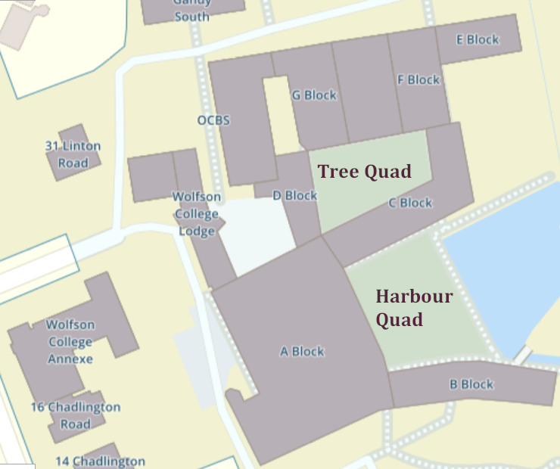

Heating and Lights:
- Switch off lights in your room and communal areas when you leave.
- Switch off lights in the library if you’re the last to leave in the evening.
- Turn off the heating if you go away for the weekend or over the vacation period. Turn off radiators when you open a window.
- It is also recommended to switch off electrical appliances at the wall/socket when not in use.
- During the summer, the heating in campus buildings is not controllable from the flats but is turned off centrally to save money. If you live outside of the main college buildings, make sure to switch off your heating in the summer.

Tips for Living Green in College:
Read about what the college is doing and what you, as a resident, can do!
https://www.wolfson.ox.ac.uk/sustainability

Drinks
Bring a reusable KeepCup when you get take-away drinks; this reduces cups going to landfill.
- Most cafés give a discount when you present a reusable cup.
- KeepCups are the only type of reusable cup permitted in the university and college libraries.
- Wolfson has its own design – you can purchase one at the café!

Buy a reusable water bottle instead of disposable plastic ones. You can find >170 water refill stations across Oxford by going to: https://wwww.refilloxford.org (they also have an app)

College Allotments
You can hire an allotment or raised bed on college grounds for growing your own fruit and veg! These cost a very small amount per month and will be added to your battels statement.
Email accommodation.office@wolfson.ox.ac.uk for prices and availability.

Birds
Please do not feed the ducks or geese in college as their droppings soil the paths. In addition, bread is harmful to them, causing deformities.

Tree Quad Store Room
We have a fantastic facility on-site for sharing our unwanted goods with others. If you have clothing, small furniture items, books, DVDs, non-perishable food, etc. that you no longer need, you can leave these in the store room in C block – this is located in the corridor between the Harbour Quad and the Tree Quad. You can also pick up many household items for free – saving you some money!
(Note: do not leave broken items here! Take these to the skip next to the F-block bicycle park.)

Join the Green Team
Wolfson has an informal group open to all members of college and staff. We collaborate to make Wolfson a more environmentally friendly place. See here: https://www.wolfson.ox.ac.uk/green-team

Green Shopping in Oxford:
Take reusable shopping bags with you. They will last a LOT longer than plastic bags!

Refill Shops:
These are places where you can bring your own containers, from jam jars to lunch boxes, and get refills on many household goods without the packaging.
- OxUnboxed (36 Little Clarendon Street) – food, toiletries, cleaning products
- Headington Fairtrade (104 London Road) – can refill any “Ecover” and “Faith in Nature” products
- Flo’s Refill Shop (The Place in the Park, Rymers Lane) – food, toiletries, cleaning products

Charity Shops and Vintage Clothing:
There are some amazing vintage clothing specialists in Oxford; check out Reign, The Ballgown Emporium, and Unicorn. We also have an abundance of charity shops with good quality clothing and accessories, so you can reduce your environmental footprint by buying second-hand.

Food and Produce:
Many places offer locally grown, plastic free fresh food. No 2 North Parade, Gail’s Bakery, Wild Honey, and The Covered Market are all permanent stockists. Regular farmers’ markets across Oxford include the Summertown Farmer’s Market (every Sunday), Gloucester Green Market, and East Oxford Market.
You can also find companies offering home delivery of local farm produce: Abundance Oxford, Cultivate Oxford, and Veg in Clover. See their individual websites for more information.

Toilet Roll:
Oxfam on Broad Street sells plastic-free toilet roll. You could also consider signing up to a company with a delivery service such as Serious Tissues, The Cheeky Panda, Who Gives a Crap, or Naked Sprout.

OxHub
OxHub offers many opportunities to volunteer with local environmental projects. See their website for information on the services and shops they run (including OxUnboxed): https://www.oxfordhub.org/

SHARE Oxford
SHARE Oxford runs regular free repair cafés (including for bikes). They also have a “Library of Things” where you can rent items that you might only need occasionally, e.g. for DIY, camping, and parties.
Wolfson also has its own bike repair workshop – see here: https://www.wolfson.ox.ac.uk/bicycles

Ecosia
Consider switching to Ecosia as your default search engine on electronic devices – the money gained from their ad revenue is used to fund tree-planting projects around the world, at no cost to you!

Get in touch with the Environmental Rep (greenteam@wolfson.ox.ac.uk) if you have any questions or suggestions. More details can be found here: https://www.wolfson.ox.ac.uk/green-team

