

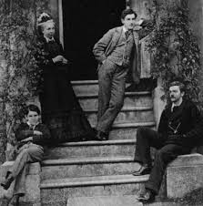

Old Wolves event

Thursday 5 November 2020

1.30 p.m. *via Zoom*

Merryn Williams on writer

**Margaret Oliphant & Oxford**

Merryn Williams (MCR) is a poet and critic. Her latest works are *The Fragile Bridge: New and Selected Poems* (Shoestring Press) and *Mansfield Park Revisited* (Plas Gwyn Books). She is currently collecting poems about the pandemic and the lockdown.

*Contact the College Archivist, Liz Baird,* [*archives@wolfson.ox.ac.uk*](mailto:archives@wolfson.ox.ac.uk) *by 12 noon on*

*Tuesday 3 November 2020 for an invitation.*

*(Download Zoom here:* [*https://zoom.us/download*](https://zoom.us/download)*)*

Image: Margaret Oliphant with her nephew and sons at their home in

Windsor c 1870s. Photographer: unknown. Source: Project Gutenberg

<http://www.gutenberg.org/ebooks/author/963>

*Event organised as part of our Old Wolves series*

*but open to all – no charge.*