College Top-ups
Overview of College Top-ups
Our student account system operates on a top-up payment basis. You will be able to put credit on your College Top-up account by making a card payment using the Wolfson Gateway online system https://gateway.wolfson.ox.ac.uk/
Once your College Top-up account is in credit, you will be able to incur charges (meals, café etc) against your account by presenting your University card at College tills. Other items (e.g. event bookings on the Gateway) can also be charged against College Top-up credit. Please note that costs for printing in the College library are charged against Top-up balances via an overnight process rather than instantly.
Initial College Top-up credit on arrival
An initial top-up credit of £30 is placed on your College Top-up account for your arrival at the College and will be charged on your September battels statement. This means that you will have £30 to spend from your University card before needing to top-up.
How to top-up your account
There is a top-up facility on the Wolfson Gateway website. Payment is made by debit or credit card.
- Go to the Wolfson Gateway site at https://gateway.wolfson.ox.ac.uk/
- Log in using your University single sign on
- Go to “Top-ups & Tills” on the main menu tabs
- Complete the payments section (example screen shot below), taking care to select “1-COLLEGE TOP-UP”. The minimum top-up is currently £10. Click “Make Payment” and fill in your debit/credit card details to make payment.

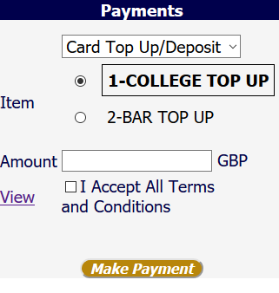
Viewing your College Top-up balance and transactions
Your College Account balance and transactions may also be viewed online on the same “Top-ups & Tills” page of the Wolfson Gateway.
Any problems?
Should you have any IT problems using this facility, please contact Wolfson IT team on it.support@wolfson.ox.ac.uk. However, if it is a banking related problem then please contact your own payment card provider.
If have any problem topping up online, credit can alternatively be put on your account via the debit/credit card machine at the following locations:
- Accounts Office in the Berlin Quad during office hours (in person or by phoning 01865 274112)
- Café till
- Dining Hall till (during quiet periods only, to avoid the queue being held up)
For any other queries on your Top-up your account, please do visit the Accounts Office or email topups@wolfson.ox.ac.uk

Bar Top-ups
The Cellar Bar operates a separate top-up system for bar purchases only. There is no initial credit on this top-up. If you wish to top-up this account, please use the same page on the Gateway to make payment but select “2-BAR TOP-UP” as per example screen shot below.
