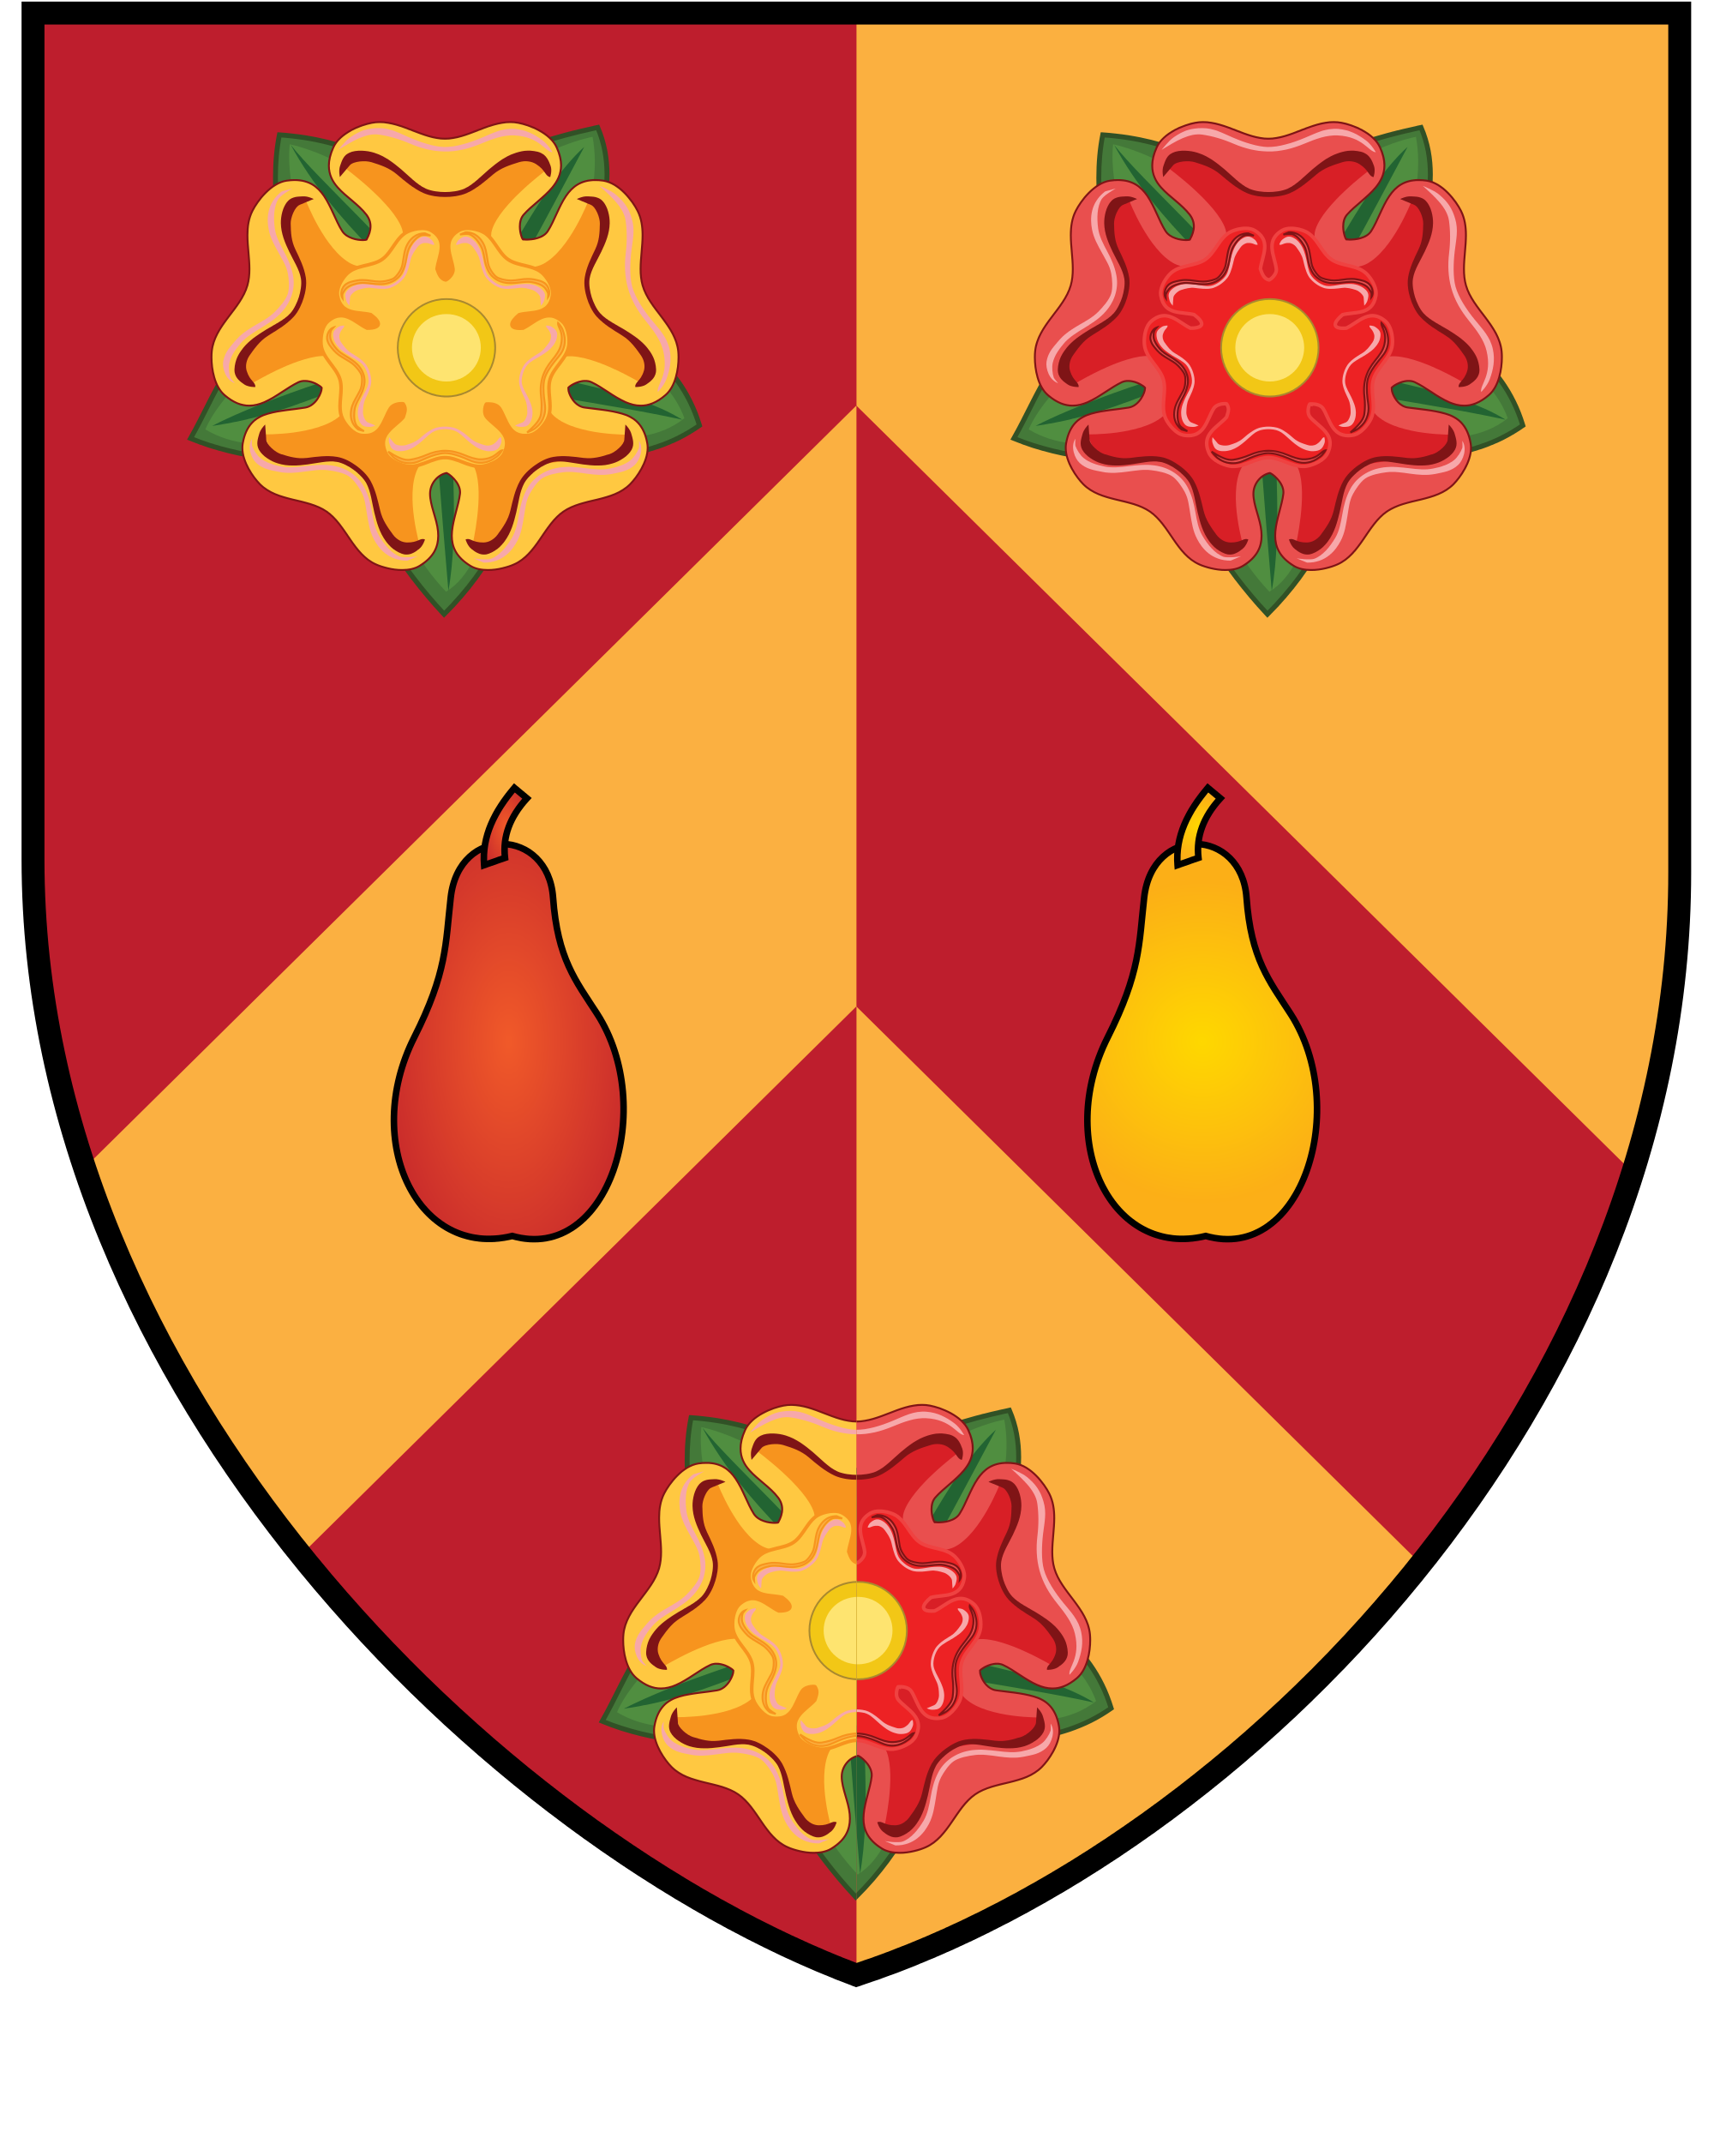
The Ancient World Research Cluster

LORNE THYSSEN RESEARCH FUND

FOR

ANCIENT WORLD TOPICS

Please type and send to Dr Diana Rodríguez Pérez at ancient.world@wolfson.ox.ac.uk with the subject “Application_Lorne Thyssen Research Fund” by the end of the 3rd week of each term. Receipt of all applications will be acknowledged by email usually within two business days. Funding guidelines available at https://www.wolfson.ox.ac.uk/clusters/ancient-world/lorne-thyssen-research-fund
Applications are considered at the Steering Committee meeting in week 6 of each term and a decision will be communicated by email shortly after.
*APPLICATIONS MUST BE MADE BEFORE EVENT TAKES PLACE*

Name of Applicant:
Wolfson Status (Battels number):
Name of Post (if applicable):

Type of Activity to be Funded:

Research grant (up to £3000/£5000) Seed-corn funds (up to £3000/£5000)
Organization of workshops, conferences, and colloquia (up to £1200/£2000)
Participation in conferences, workshops, colloquia, or academic exchanges (up to £400/£1000)
Field work (up to £1200) Support for publication of scholarly work (up to £2000)
Other (please, specify):
Brief Summary of Activity (50 words max.): Amount Requested:

Other Sources of Funding. Please list any other sources of funding you have applied for this project and the amount requested. If no other sources have been sought, please explain briefly why.

Previous Applications. If you have previously received financial assistance from the Lorne Thyssen Research Fund, please, give dates (term and year), type of activity funded, and amount granted.

Checklist (for the applicant):
Description of activity (in this document) Budget (in this document) Support letter requested to supervisor (GS)
CV attached (all but Fellows, ie. GS, MCR, VS)

Description of the Activity to be Funded

Budget

The “Description of the activity to be funded” and the “Budget” should not exceed 2 pages (3 for conferences).

